# CHICKEN DRUMMETES...$15

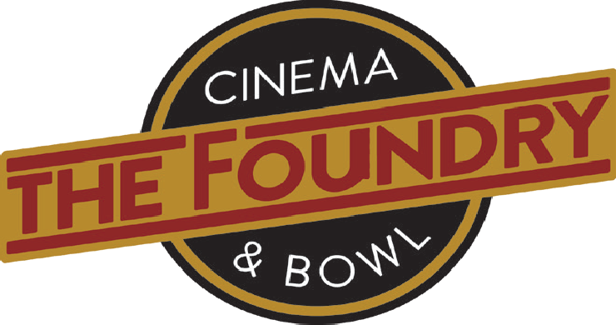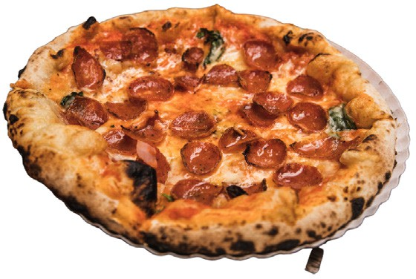

FRAME

APPROACH

Legendary Colorado Red Bird Farm Chicken. Tossed in your choice of Classic Buffalo, Chipotle, Garlic Serrano, Teriyaki or BBQ. Served with Carrots & Celery with your choice of Bleu Cheese or Ranch

# WISCONSIN CHEESE CURDS...$10

Fried White Cheddar Curds served with Marinara or Ranch

# PRETZEL BITES...$9

Served with Beer Cheese and Brown Mustard

# PARMESAN TRUFFLE FRIES...$10

Crispy fries with Truffle Oil & Parmesan Cheese

# BASKET OF FRIES...$8 SWEET POTATO FRIES...$10 ONION RINGS...$9 CHICKEN TENDERS...$12

Choice of sauces: Buffalo, Ketchup, Honey Mustard, Ranch or BBQ

# WINTER PARK CEASAR SALAD...$12 MEATBALL SUB... $14

House made Meatballs, Marinara, Mozzarella served on a Amarosa Roll

# PROSCIUTTO SANDWICH...$16

Thin sliced prosciutto, roasted red pepper, mozzarella, parmesan, lettuce, basil, house sauce on a Amorosa Roll

PERFECT GAME

Brick Oven Pizza & Calzones

# CLASSIC CHEESE... $12 PEPPERONI... $14

**FRASER VALLEY VEGGIE...$15**

Bell Peppers, Black Olives, Mushrooms, Onions

**SUPREME... $16**

Sausage, Bell Peppers, Black Olives, Mushrooms, Onions

# THE CARNIVORE... $17

Pepperoni, Sausage, Bacon

**CALZONES...** Cut into 8 shareable pieces, served with a side of homemade Marinara.

***Fresh Basil May be added to any Pizza or calzone for a $1.50***

***All Pizzas are a 12” Crust / Gluten Free Available $2 additional***

# MINI CANNOLI’S...$10/3 $15/5

...Add Chocolate chips $1.50

...Add Peanut Butter Maple Glaze $2.00

# TIRAMISU...$13

Espresso & Rum-soaked lady fingers layered with house made ricotta-mascarpone cream topped with cocoa powder.